Mental Help Seeking Intention Scale (MHSIS)
Recommended 2026 Version

Note: For more help-seeking resources, including theory, constructs, and measures, please visit HelpSeekingResearch.com.

Note: Visit http://drjosephhammer.com/research/mental-help-seeking-intention-scale-mhsis/ for information on how to administer, score, interpret, discuss the reliability and validity of, consider the limitations of, and obtain permission to use the MHSIS in its various formats, versions, and translations.

Note: Hammer and colleagues (2026) synchronized the language of six measures (i.e., Mental Help Seeking Attitude Scale [MHSAS], Perceived Norm: Injunctive Scale [PN:IS], Perceived Norm: Descriptive Scale [PN:DS], Personal Agency: Autonomy Scale [PA:AS], and Personal Agency: Capacity Scale [PA:CS], Mental Help Seeking Intention Scale [MHSIS]) to a shared definition of mental health help-seeking behavior and provided evidence of reliability and validity for these six synchronized measures. This battery of measures - known as the Integrated Behavioral Model of Mental Health Help Seeking Questionnaire (IBM-HS-Q) - assesses central constructs of the Integrated Behavioral Model of Mental Health Help Seeking (IBM-HS), including the three mechanisms (attitude, perceived norm, personal agency) and intention. This 2026 version of the MHSIS is drawn from this synchronized IBM-HS-Q battery.

Note: this recommended 2026 version differs from the original 2018 version in several ways:
- The 2026 version uses a 6-point Likert scale instead of the old 7-point Likert scale that that 2018 version used.
- Instead of each MHSIS item using the prefix of “If I had a mental health concern…” (which was the case for the 2018 version), the questionnaire instructions for the 2026 version provide a hypothetical mental health concern scenario that participants should imagine themselves in when completing the MHSIS items. Both the original 2018 version and revised 2026 version of the MHSIS measure conditional intention, in that intention scores are predicated on their own imagination of what “mental health concern” might look like for them (for 2018 version) or the hypothetical condition articulated in the mental health concern scenario vignette (for 2026 version). Please note, however, that the MHSIS can be adjusted (e.g., “I intend to…”) to measure intention unconditionally, which would involve asking participants to answer the three MHSIS questions based on how they feel right now in real life and does not involve providing them with a scenario vignette (for 2026 version) nor including a prefix (“If I had a mental health concern…”). Read Step 2 of the IBM-HS mixed-method protocol webpage (https://www.helpseekingresearch.com/theory/ibm-hs/applications/mixed-method-protocol/) for guidance on aligning the MHSIS and other reasoned action tradition measures with the TACT principle.
- Starting in 2026, Dr. Hammer included the timeframe of “in the next 3 months” in the item stems, as part of aligning the MHSIS with the remaining IBM-HS-Q measures.
- Dr. Hammer encourage users of the MHSIS to use the below “2026 Version” instead of the old 2018 format.

Please note that it is not advised to list the name of the scale for participants to view. That may bias their responses. It is better to list the abbreviation, if you must label the instrument for the respondents’ eyes.

Questionnaire Instructions

For the purposes of this questionnaire, “mental health professionals” include psychologists, psychiatrists, clinical social workers, and mental health therapists and counselors.

As you answer the questions in this questionnaire, we would like you to imagine something.

Imagine that you have been experiencing a serious mental health concern for the last month. You feel significantly more nervous, restless, hopeless, and isolated, and are having trouble sleeping and concentrating on your work.

We’re going to ask you some questions about how you—given your personal views and experiences to date—might feel about seeking help from a mental health professional if you were dealing with this hypothetical mental health concern right now.

1. I would intend to seek help from a mental health professional in the next 3 months.

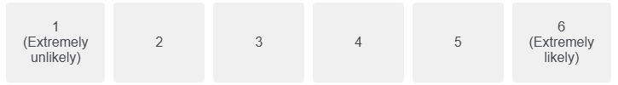

2. I would try to seek help from a mental health professional in the next 3 months.
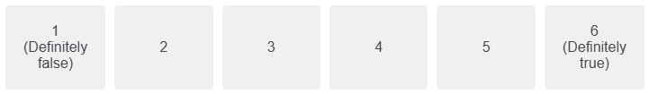

3. I would plan to seek help from a mental health professional in the next 3 months.
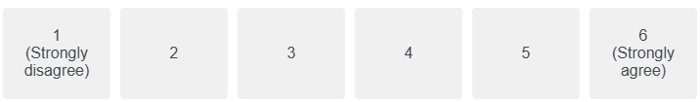

Scoring Key and Suggestions for Valid Administration of the MHSIS
- No reverse scoring is necessary.
- The MHSIS contains three items which produce a single mean score to measure a single intention dimension/factor.
- To calculate the mean score, add the scores for all three items then divide by three.
- The resulting mean score should range from a minimum of 1 to a maximum of 6 (if using the 2026 version that uses the 6-point Liker scaling).
- Regarding calculating mean scores in the presence of missing data:
  - Do not calculate a mean for a participant who is missing any data on the 3 items.
- If you are administering this measure alongside other reasoned action tradition-based measures, it is best to intersperse these three items among the other reasoned action tradition-based measure items, in a nonsystematic order (see Ajzen, 2006).
  - Note: reasoned action tradition-based measures include the Theory of Reasoned Action (TRA), Theory of Planned Behavior (TPB), Integrative Model of Behavioral Prediction (IMBP), Integrated Behavioral Model (IBM), and Integrated Behavioral Model of Mental Health Help Seeking Questionnaire (IBM-HS-Q).
- If you are administering this measure alongside other reasoned action tradition-based measures, to ensure that all participants are interpreting the terminology in this measure and other TRA/TPB/IMBP/IBM/IBM-HS-Q measure items consistently, we recommend including the Questionnaire Instructions (see above) in the survey prior to participants completing any MHSIS items and other TRA/TPB/IMBP/IBM/IBM-HS-Q measure items, whether immediately prior, or toward the start, of the entire survey. When measuring these help-seeking constructs conditionally, such as by using a hypothetical mental health concern vignette scenario, it is important for responses to all TRA/TPB/IMBP/IBM/IBM-HS-Q measure items to reflect people’s conditional perceptions. This consistency is important to ensure compliance the reasoned action tradition’s TACT principle. Read Step 2 of the IBM-HS mixed-method protocol webpage (https://www.helpseekingresearch.com/theory/ibm-hs/applications/mixed-method-protocol/) for guidance on aligning the MHSIS and other reasoned action tradition-based measures with the TACT principle.

