Mental Help Seeking Intention Scale (MHSIS)

INSTRUCTIONS: For the purposes of this survey, “mental health professionals” include psychologists, psychiatrists, clinical social workers, and counselors. Likewise, “mental health concerns” include issues ranging from personal difficulties (e.g., loss of a loved one) to mental illness (e.g., anxiety, depression). Please mark the box that best represents your opinion.

If I had a mental health concern, I would intend to seek help from a mental health professional.
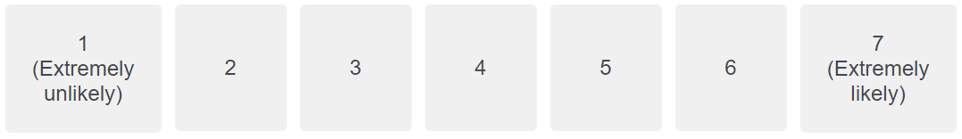

If I had a mental health concern, I would try to seek help from a mental health professional.
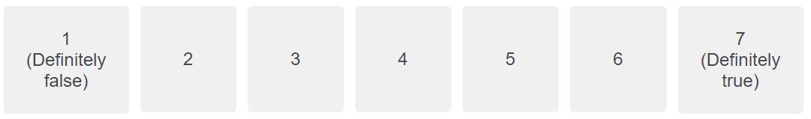

If I had a mental health concern, I would plan to seek help from a mental health professional.
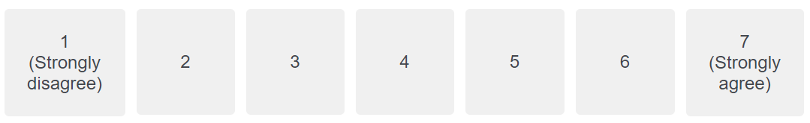

Scoring Key
The MHSIS contains three items which produce a single mean score. To calculate the mean score, add the scores for all three items then divide by three. The resulting mean score should range from a minimum of 1 to a maximum of 7. Do not calculate a MHSIS mean for a participant who is missing any data on the MHSIS. If you are administering the MHSIS alongside other Theory of Planned Behavior (TPB) items, it is best to intersperse these three MHSIS items among the other TPB items, in a nonsystematic order (see Ajzen, 2006). If you do so, to ensure that all participants are interpreting the terminology in the MHSIS items consistently, we recommend including the MHSIS instructions (see above) in the survey prior to participants completing the MHSIS items, whether immediately prior, or toward the start of the entire survey.

*Visit http://drjosephhammer.com/research/mental-help-seeking-intention-scale-mhsis/ for information on how to administer, score, interpret, discuss the reliability and validity of, consider the limitations of, and obtain permission to use the MHSIS.

